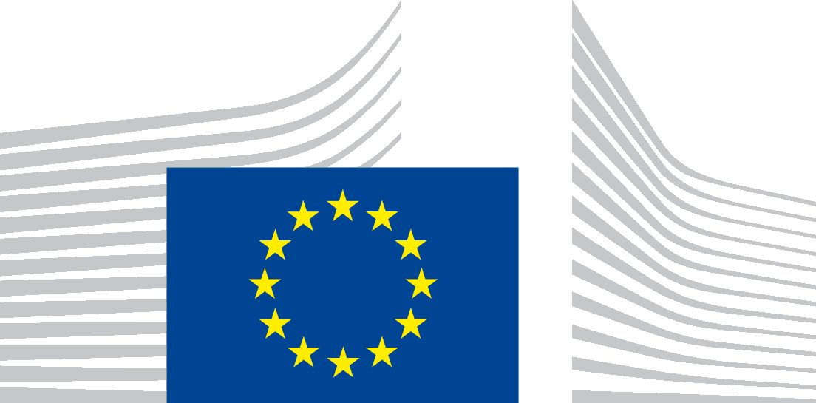 | EUROPEAN COMMISSION  DIRECTORATE-GENERAL  TAXATION AND CUSTOMS UNION  International and General Affairs  Management of programmes and EU Training
Brussels,
TAXUD.E.3 (2022)
Note to the Customs Programme Coordinators
In Austria, Czech republic and latvia
Subject: Invitation to the CLEP workshop – Sniffer Dogs Training
03 – 07 October 2022, Gajary (Slovakia)
Event Code: CTR/013/001
Following the call for interest sent on 26 July (TAXUD.E.3/SR (2022) 5 843 809), the selected participants (Annex 1) from your Administration are invited to participate in the above-mentioned CLEP event organized by the Financial Administration of the Slovak Republic.
Registration forms should be completed by participants and sent back as soon as possible and by 16 September 2022 at the latest. In parallel, Programme Coordinators are requested to register their participants in the Activity Reporting Tool by the same deadline.
Officials attending events organised under the programmes have to fulfil the reporting obligation under the Monitoring and Evaluation Framework (MEF) of the programme by providing feedback through a dedicated survey when requested. Programme Coordinators should encourage participants to meet this obligation.
In case of a problem encountered during registration in ART, Programme Coordinators are invited to contact taxud-customs-programme@ec.europa.eu.

Stéphane Mail Fouilleul
Head of Unit
Cc.: Customs TSG representatives (via PICS)
Enclosures: 1. List of participants
2. Programme
3. Agenda
4. Privacy statement
5. Registration form

EUROPEAN COMMISSION
DIRECTORATE-GENERAL
TAXATION AND CUSTOMS UNION
Name of Directorate
Name of Unit

ANNEX 1

List of invited participants:

Ms. Reuter Beatrix (Austria)
Mr. Konrad Stefan (Austria)
Ms. Lenka Dyntarová (Czech Republic)
Mr. Filip Gavor (Czech Republic)
Ms. Jelena Tretjakova (Latvia)
Mr. Valdis Bikovskis (Latvia)

ANNEX 2
CUSTOMS PROGRAMME

Subject/Title | Sniffer Dogs Training Workshop
Event code | CTR/013/001
Date and duration | 03 – 07 October 2022  5 days
City (Country Code) | Gajary /Slovakia (SK)
Address | Sniffer Dogs Training Centre  Výcvikové stredisko služobnej kynológie Gajary 1047,  900 61, Gajary  https://maps.app.goo.gl/qnQW6zZ6uJBLvsQGA  48°28'05.1"N 16°53'46.2"E

Background | The event is organised by the Financial Administration of the Slovak Republic in cooperation with CELBET under Common Learning Events Programme (CLEP) of the Customs Programme. The key objective of the CLEP programme is to allow Participating countries to deliver Learning and Development activities to national trainers, subject matter experts, and experts with teaching practice. CLEP enables national administrations to benefit from existing knowledge and expertise in the field of customs or from training specifically designed as a CLEP to enhance the training capacity or the professionalism of public administrations. This training aims at improving the training methodology of sniffer dogs trained for the detection of narcotics, tobacco and financial cash.
Objectives | The objective of this training is to improve the vocational skills of the service dogs and the Customs officers working as dog handlers at the EU´s external border and to exchange the practical experience and best practices in the field of training and use of service dogs to search for narcotics and psychotropic substances, tobacco and tobacco products, as well as financial cash. Mutual cooperation of dog handlers and sniffer dogs from different countries and comparison of training methods directly in the training process will contribute to the preparation and training of sniffer dogs, with the aim to protect the financial interests of the EU and the Member States and to ensure the safety and security and protection of citizens in a more effective way.
Expected outcome | The improved training techniques of dog handlers for sniffer dogs will increase the effectiveness of the control at the border and strengthen the protection of the EU's financial interest.  Presentation of specialized training targeted to dog handlers and sniffer dogs to improve the vocational skills of the sniffer dogs and dog handlers.  Exchange of theoretical and practical experience in the field of sniffer dogs training methodology and use of sniffer dogs to search for narcotics and psychotropic substances, tobacco and tobacco products, as well as financial cash.
Methodologies | - Presentations of the service cynology methodologies  - Practical demonstrations, working with service dogs  - Discussions and sharing best practices
Interpretation/ working language | English  No interpretation will be provided.
Number and profile of participants | Financed under the Programme budget :  2 experts per invited Member State  (see List of invited participants – Annex 1)  Total number of participants: 6  Participant´s profile:  - Customs officers working as dog handlers at the EU external border  - Experienced dog handlers with sniffer dogs – member groups of K9 teams of participating countries  - Dogs with previous experiences in Tobacco, Drugs, CITES or Cash searching
Participant preparation | Veterinary conditions of transit:  Participants coming with dogs should find out the veterinary conditions of transit of countries through which they will travel, as well as the conditions of entry into Slovakia with dogs from their country.  Information for Slovakia: State Veterinary and Food Administration of the SR (State Veterinary and Food Administration of the SR (svps.sk))
Registration | Each Customs Programme Coordinator is requested to complete the attached Registration Form, providing details of participants, and to send it as soon as possible and by 16 September 2022 at the latest to the email addresses:  eva.kanova@financnasprava.sk and anna.grabowska11@mf.gov.pl with a copy to the (taxud-customs-programme@ec.europa.eu )  Participants should contact their Customs Programme Coordinator before confirming participation and/or making any travel arrangements.
Accommodation (location, contact details and price) | Accommodation for the participants will be provided at the Sniffer Dogs Training Centre Gajary (Slovakia) free of charge. Accommodation is provided with fully equipped kitchen and laundry facilities.
Meals | Participants arrange their food themselves (a small pizzeria and a 2 grocery stores can be found about 2,5 km from the training centre, there is also food delivery to the training centre from several restaurants in the area - the average price of the lunch menu is 7 euros).
Reimbursement | - The most appropriate and cost-effective way of travelling has to be chosen with a view to reimbursement of expenses.  - The accommodation unit cost for Slovakia amounts to EUR 98 per night.  - The daily allowance unit cost for Slovakia amounts to EUR 74.  - Travel and living expenses will be covered under the conditions specified in the financial guide.
Information concerning travel (airport-venue etc.) | Participants will need to arrange their own transport from their home countries.  https://maps.app.goo.gl/qnQW6zZ6uJBLvsQGA  48°28'05.1"N 16°53'46.2"E
Host coordination | The host contact person for the training is:  Ms. Eva Kanová, email: eva.kanova@financnasprava.sk
Central coordination | European Commission  Taxation and Customs Union Directorate General  Programme Management Team  TAXUD-CUSTOMS-PROGRAMME@ec.europa.eu

ANNEX 3

CLEP - Sniffer Dogs Training Workshop
gajary (sk), 03 – 07 October 2022
CTR/013/001

Draft AGENDA

02 October 2022 (Day 0)
Arrival of the participants to the Sniffer Dogs Training Centre in Gajary
03 October 2022 (Day 1)
09:00 – 10:00 Presentation of the service cynology of the Slovak Financial Administration
10:00 – 12:00 Presentation of the service cynology of the participating Member State
12:00 – 13:00 Setting up a training program, dividing up tasks
13:00 – 14:00 Lunch
14:00 – 17:00 Practical demonstrations at the Sniffer Dogs Training Centre – methodology for training and training of the Financial Administration service dogs
04 October 2022 (Day 2)
09:00 – 12:00 Division into groups by focus, working with service dogs at the Sniffer Dogs Training Centre
12:00 – 13:00 Lunch
13:00 – 17:00 Working with service dogs at the Gajary School building
05 October 2022 (Day 3)
09:00 – 12:00 Working with service dogs at the Sniffer Dogs Training Centre (alternative workplace: military forest management facility in Malacky, distance 15 km)
12:00 – 13:00 Lunch
13:00 – 17:00 Working with service dogs at the Training Centre of Police in Malé Leváre (distance 10 km)

06 October 2022 (Day 4)
09:00 – 12:00 Working with service dogs at the Sniffer Dogs Training Centre (alternative workplace: area of the Slovak Railways in Bratislava, distance 60 km)
12:00 – 13:00 Lunch
13:00 – 14:30 Working with service dogs at the Sniffer Dogs Training Centre (alternative workplace: area of the Slovak International Airport in Bratislava, distance 60 km)
14:30 – 17:00 Visit of Museum of Customs (Devínska Nová Ves)
07 October 2022 Day 5)
09:00 – 11:00 Working with service dogs at the Sniffer Dogs Training Centre
11:00 – 12:00 Evaluation of the training (handing over the certificates to the participants)
12:00 – 13:00 Lunch
13:00 – 17:00 Special training at the Sniffer Dogs Training Centre

Instructors:
Ms. Dana Borghouts (Slovakia)
Mr. Lukáš Čurilla (Slovakia)
Ms. Eva Klímová (Slovakia)
Mr. Jozef Klíma (Slovakia)

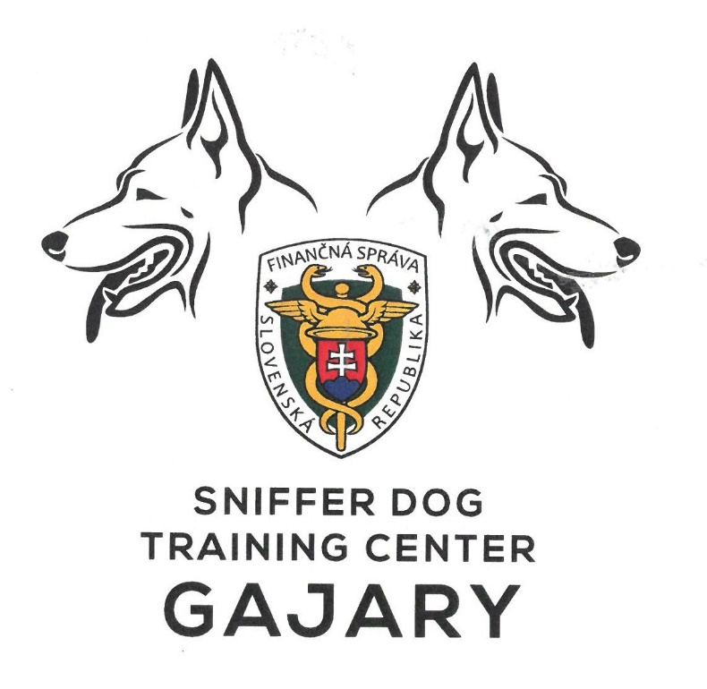

ANNEX 4
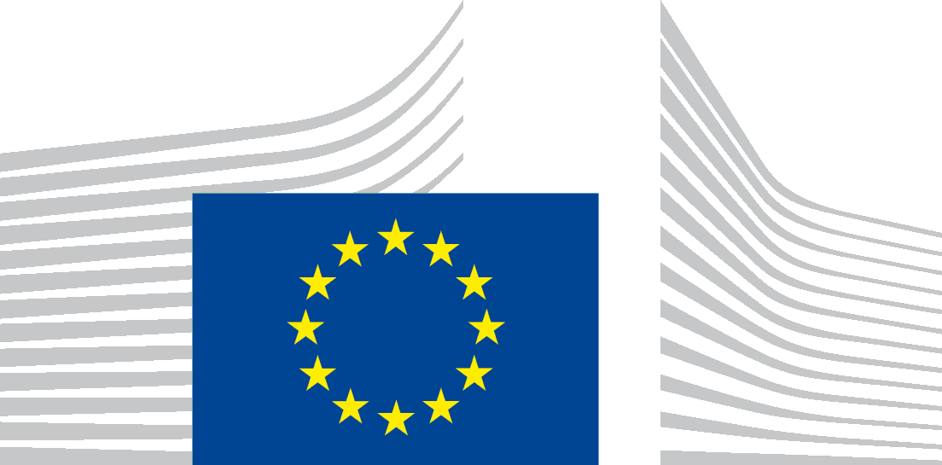 | EUROPEAN COMMISSION
PROTECTION OF YOUR PERSONAL DATA
This privacy statement provides information about the processing and the protection of your personal data.
Processing operation: Organisation and management of meetings in the context of the Customs and Fiscalis programmes for meetings that are not linked to expert groups.
Data Controller: European Commission, Directorate-General Taxation and Customs Union, Unit E3
Record reference: DPO-3078-5

Table of Contents
- Introduction
- Why and how do we process your personal data?
- On what legal ground(s) do we process your personal data?
- Which personal data do we collect and further process?
- How long do we keep your personal data?
- How do we protect and safeguard your personal data?
- Who has access to your personal data and to whom is it disclosed?
- What are your rights and how can you exercise them?
- Contact information
- Where to find more detailed information?
- Introduction
The European Commission (hereafter ‘the Commission’) is committed to protect your personal data and to respect your privacy. The Commission collects and further processes personal data pursuant to Regulation (EU) 2018/1725 of the European Parliament and of the Council of 23 October 2018 on the protection of natural persons with regard to the processing of personal data by the Union institutions, bodies, offices and agencies and on the free movement of such data.
This privacy statement explains the reason for the processing of your personal data, the way we collect, handle and ensure protection of all personal data provided, how that information is used and what rights you have in relation to your personal data. It also specifies the contact details of the responsible Data Controller with whom you may exercise your rights, the Data Protection Officer and the European Data Protection Supervisor.
This privacy statement concerns the processing operation Organisation and management of meetings in the context of the Customs and Fiscalis programmes for meetings that are not linked to expert groups undertaken by the European Commission Directorate-General Taxation and Customs Union, unit E3, as presented below.
- Why and how do we process your personal data?
Purpose of the processing operation: The European Commission collects and uses your personal information only for the organisation, preparation, management and follow-up of meetings financed through the Customs and Fiscalis programmes that are not expert group meetings. More specifically, this concerns the following processing activities:
- communication activities such as sending e-mails and invitations (this entails the management of contact lists for correspondence);
- exchange of meeting documents (notably through information sharing and circulation of documents via
  - e-mail, and/or
  - the Advanced Gateway to EU Meetings (AGM) online system for meeting organisation (see Record of processing DPR-EC-01141 - Information system supporting the organisation of meetings (former notification DPO-3911)), and/or
  - CIRCABC (see Record of Processing DPR-EC-01666 - CIRCA and CIRCABC – Global User Directory (former notification DPO-1008))) and/or,
  - ART2 (see DPR-EC-04047.1).
- organisational and administrative activities to ensure the participants' access to Commission premises (see Record of Processing DPR-EC-00655 (Commission Physical Access Control System (PACS)));
- reimbursement of travel, subsistence costs or payment of special allowances in the sense of Article 21 of Commission decision C(2016) 3301 (see Record of Processing DPR-EC-00301 - Legal Entities and Bank Accounts (former notifications DPO-372 and DPO-300 and ART2 (see DPR-EC-04047.1));
- audio-visual recording of the meetings for the purpose of drafting minutes (see Record of Processing DPR-EC-01937 (Audio-visual recording of meetings));

Your personal data will not be used for an automated decision-making including profiling.

- On what legal ground(s) do we process your personal data
We process your personal data, because processing is necessary for the performance of a task carried out in the public interest (Article 5(1)(a) of Regulation (EU) No 2018/1725).
Bringing together customs and tax officials in different types of meetings plays an important role in enabling the Member States' authorities to improve cooperation, exchange expertise, build confidence, share knowledge as a basis for respectively supporting the functioning and modernisation of the customs union (customs) and improving the proper functioning of the taxation systems in the internal market (Fiscalis-taxation).
- Which personal data do we collect and further process?
In order to carry out this processing operation the Data Controller may collect the following categories of personal data:
- Personal data necessary for organising and managing meetings such as gender (Mr/Ms), name, organisation to which he/she belongs, e-mail address, phone/fax number;
- Personal data necessary for security (access control to Commission premises) such as ID card/Passport number and date of birth, name, surname, organisation he/she belongs to, gender;
- Personal data necessary for reimbursements purposes such as name, means of transport, hotel accommodation and banking details;
- Personal data necessary for payment of special allowances, such as name and banking details;
- Personal data included in the minutes of meetings, such as names of meeting participants and their positions expressed (in case of representatives of organisations, Member States’ authorities and other public entities, only based on their prior freely given, specific, informed and unambiguous consent, if at all).
- Personal data necessary for establishing the attendance list and the minutes: signature, audio-visual recording of the meeting.
If you do not provide these personal data, possible consequences are the impossibility to attend meetings and/or to be reimbursed or paid.
We have obtained your personal data either directly from you, via the competent National department, another public entity or organisation that you work for or via the Permanent Representation of your country in Brussels.

- How long do we keep your personal data?
The Data Controller only keeps your personal data for the time necessary to fulfil the purpose of collection or further processing, namely for a maximum of 5 years after closure of the file to which the personal data processed belongs.
The ‘administrative retention period’ of five years is based on the retention policy of Commission documents and files (and the personal data contained in them), governed by the common Commission-level retention list for European Commission files (SEC(2019)900).
It is a regulatory document in the form of a retention schedule that establishes the retention periods for different types of Commission files. That list has been notified to the European Data Protection Supervisor.
The ‘administrative retention period’ is the period during which the Commission departments are required to keep a file depending on its usefulness for administrative purposes and the relevant statutory and legal obligations.
This information is without prejudice to longer retention periods which may apply to personal data processed for the purpose of reimbursing travel and subsistence costs, payment of special allowances and ensuring the participant's access to Commission premises based on the dedicated processing operations notified to the DPO by the responsible Commission departments (Records of Processing DPR-EC-00655 (Commission Physical Access Control System (PACS)) and DPR-EC-00301 - Legal Entities and Bank Accounts (former notifications DPO-372 and DPO-300)).
- How do we protect and safeguard your personal data?
All personal data in electronic format (e-mails, documents, databases, uploaded batches of data, etc.) are stored on the servers of the European Commission All processing operations are carried out pursuant to the Commission Decision (EU, Euratom) 2017/46 of 10 January 2017 on the security of communication and information systems in the European Commission.
The Commission’s contractors are bound by a specific contractual clause for any processing operations of your data on behalf of the Commission, and by the confidentiality obligations deriving from the General Data Protection Regulation in the EU Member States (‘GDPR’ Regulation (EU) 2016/679).
In order to protect your personal data, the Commission has put in place a number of technical and organisational measures. Technical measures include appropriate actions to address online security, risk of data loss, alteration of data or unauthorised access, taking into consideration the risk presented by the processing and the nature of the personal data being processed. Organisational measures include restricting access to the personal data solely to authorised persons with a legitimate need to know for the purposes of this processing operation.
- Who has access to your personal data and to whom is it disclosed?
Access to your personal data is provided to the Commission staff authorised for carrying out this processing operation and to other authorised Commission staff according to the “need to know” principle. Such staff abide by statutory, and when required, additional confidentiality agreements.
More specifically, the following Commission staff have access to certain parts of the personal data:
- Authorised staff of the European Commission's Directorate-General for Human Resources and Security have access to the personal data necessary for providing access to European Commission premises;
- Authorised staff of the European Commission's Directorate-General for Budget and the Paymaster Office (PMO) have access to the personal data needed for reimbursement purposes and payment of special allowances;
- Authorised staff of the European Commission's Directorate-General for Interpretation (SCIC) as meeting room and equipment providers have access to the audio-visual recordings of the meetings;
- Authorised staff of other European Commission departments involved in the policy follow-up to a specific meeting.
- Authorised staff in the Member States responsible for the management of the Customs and Fiscalis programmes.
Please note that pursuant to Article 3(13) of Regulation (EU) 2018/1725, public authorities (e.g. Court of Auditors, EU Court of Justice) which may receive personal data in the framework of a particular inquiry in accordance with Union or Member State law shall not be regarded as recipients. The further processing of those data by those public authorities shall be in compliance with the applicable data protection rules according to the purposes of the processing.
The information we collect will not be given to any third party, except to the extent and for the purpose we may be required to do so by law.
- What are your rights and how can you exercise them?
You have specific rights as a ‘data subject’ under Chapter III (Articles 14-25) of Regulation (EU) 2018/1725, in particular the right to access your personal data and to rectify them in case your personal data is inaccurate or incomplete. Under certain conditions, you have the right to erase your personal data, to restrict the processing of your personal data, to object to the processing and the right to data portability.
You have the right to object to the processing of your personal data, which is lawfully carried out pursuant to Article 5(1)(a) of Regulation (EU) 2018/1725, on grounds relating to your particular situation.
To the extent you consented to the publication of some of your personal data, you can withdraw your consent at any time by notifying the Data Controller. The withdrawal will not affect the lawfulness of the processing carried out before you have withdrawn the consent.
You can exercise your rights by contacting the Data Controller, or in case of conflict the Data Protection Officer. If necessary, you can also address the European Data Protection Supervisor. Their contact information is given under Heading 9 below.
Where you wish to exercise your rights in the context of one or several specific processing operations, please provide their description (i.e. their Record reference(s) as specified under Heading 10 below) in your request.
Any request for access to personal data will be handled within one month. Any other request mentioned above will be addressed within 15 working days.
- Contact information
- The Data Controller
If you would like to exercise your rights under Regulation (EU) 2018/1725, or if you have comments, questions or concerns, or if you would like to submit a complaint regarding the collection and use of your personal data, please feel free to contact the Data Controller:
European Commission, Directorate-General Taxation and Customs Union, unit E3 at TAXUD-UNIT-E3@ec.europa.eu
Financial Directorate of the Slovak Republic at international@financnasprava.sk
- The Data Protection Officer (DPO) of the Commission
You may contact the Data Protection Officer (DATA-PROTECTION-OFFICER@ec.europa.eu) with regard to issues related to the processing of your personal data under Regulation (EU) 2018/1725.
- The European Data Protection Supervisor (EDPS)
You have the right to have recourse (i.e. you can lodge a complaint) to the European Data Protection Supervisor (edps@edps.europa.eu) if you consider that your rights under Regulation (EU) 2018/1725 have been infringed as a result of the processing of your personal data by the Data Controller.
- Where to find more detailed information?
The Commission Data Protection Officer (DPO) publishes the register of all processing operations on personal data by the Commission, which have been documented and notified to him. You may access the register via the following link: https://ec.europa.eu/dpo-register/.
This specific processing operation has been included in the DPO’s public register with the following Record reference: DPO-3078-5.

