1.1. Read the phrases. Which ones do you usually use at work? Which ones do you usually hear from travellers?

INSTRUCTIONS AT THE CUSTOMS

Would you please follow me?  Pull over to the right/the left, please.  Drive in that line for a few meters, up to the officer, please.  Please get out of your car.  OK, you can continue your journey.  Please wait in the car, all of you.  Please wait in front of/behind the car.  Please wait on the right/left side.  This is for security reasons.  Would you please open your boot?  Please let me open that/this.  Take this piece of luggage out of the car and carry it into the office over there.  Put these pieces of luggage on this table.  Would you please open your bag/this suitcase?  Unpack this suitcase/this bag/this briefcase, please.  Take a seat, please. Sit down, please. | Stand up, please.  Stand aside, please.  What's that? Who does this belong to?  What's that? Whose is this?  You can repack your suitcase and continue your journey.  We have to check your car in more detail, please follow us to the garage over there.  Possible Questions and Answers of the Traveller  Why do I have to follow you?  What's up? What's going on?  That doesn't belong to me / That's not mine.  Why do I have to wait in the car?  How long will this take?  I am in a hurry, I can't wait that long / for so long.  What are you doing there?

ASKING ABOUT GOODS

Do you have anything to declare?  Have you got anything to declare?  Are you carrying any goods/gifts/souvenirs with you?  Are you carrying any alcoholic beverages, meat, milk products, cigarettes or tobacco with you?  Have you had any repairs done to your car abroad?  May I see the receipt / invoice, please? | Possible Questions and Answers of the Traveller  No, I don't have anything to declare.  No, I haven't got anything to declare.  I am sorry, I don't have a receipt/invoice.  Yes, I have the following goods to declare.  I think all together is worth about € 128  I think everything together has a value of about € 128.  No, the goods aren't worth that much.  How much tax do I have to pay for that?  I am not prepared / willing to pay that much duty.  Can I return the goods?

1.2. Match the phrases on the left to the phrases on the right.

1. Would you please follow me? | a) What's up?
2. Pull over to the right/the left, please. | b) Why do I have to unpack this suitcase/this bag/this briefcase?
3. Please get out of your car. | c) I’m sorry, I can’t put it on, it’s too heavy, could you help me?
4. Please wait in the car. | d) Could you help me, please?
5. Would you please open your boot? | e) Certainly, here you are
6. Take this luggage out of the car and carry it into the office over there. | f) Can I sit here?
7. Put this luggage on this table | g) Why do I have to follow you?
8. Would you please open your bag/this suitcase? | h) Why do I have to wait in the car?
9. Unpack this suitcase/this bag/this briefcase, please. | i) Shall I switch off the engine?
10. Sit down, please. | j) Do you have trolleys here?

2. Read the conversation. Which phrases could be useful in your work?
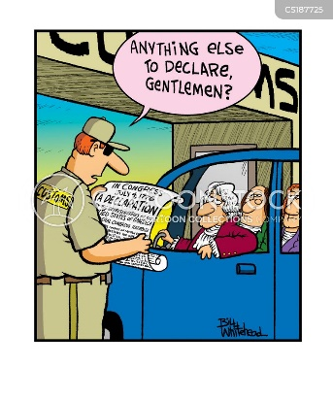
Going through Customs

Customs office: Would you mind putting your baggage on here, please ma’am? Where are you traveling from?
Page: From Marseille.
Customs officer: Marseille. Are you a resident in France, or do you live in the United States?
Page: I live in France.
Customs officer: Can I see your passport, please?... Thank you. How long are you staying in the USA?
Page: For 5 days.
Customs officer: And what's the purpose of your visit ma’am?
Page: I'm here on business.
Customs officer: I see. Well then, you understand that you've come into the Green Channel, which means you have nothing to declare.
Page: Yes.
Customs officer: Is this all your baggage?
Page: Yes, that's all.
Customs officer: Is anybody else traveling with you, ma’am?
Page: No, I'm traveling alone.
Customs officer: OK then. What type of goods have you got; cigarettes, cigars...?
Page: No, I don't smoke.
Customs officer: Nothing else at all in the tobacco line?
Page: No.
Customs officer: Any drinks at all? Spirits? Liquors? Wine?
Page: Just two bottles of red wine.
Customs officer: Were those bottles purchased in the duty-free shop, or...?
Page: Yes, at Marseille airport.
Customs officer: I see. Are you bringing any gifts for anybody in the States?
Page: Well, the wine is a present, but that's all.
Customs officer: Any other valuable items - jewelry, laptop?
Page: No, just my personal things.
Customs officer: OK. Thank you, ma’am. Would you let me have a look in there...Is the laptop going back to France with you?
Page: Yes, of course. It's my working tool.
Customs officer: Do you have a camera?
Page: No, I don't.
Customs officer: That's fine. Thank you very much. Have a pleasant stay!

3.1. Match the words on the left to their definitions on the right.
1. health certificate  2. vaccination certificate  3. pedigree  4. license  5. vet  6. value  7. allowance  8. excess | a) how much money you can sell something for  b) a document recording a person's or animal's physical state or health  c) an official document that shows you are allowed to do or have something  d) a larger amount of something than is usual or is needed  e) a list of the parents and other relatives of an animal  f) the document that shows what injections a person or an animal has  g) an amount of something that you are allowed  h) a doctor for animals

3.2. Read the conversation between a customs officer Charley and a French couple going through customs post by car. Fill in the gaps with the words/phrases from the box.
will deal, duty free, presents, total, vaccination certificate, value, to examine, the pedigree, allowance, no use arguing, in excess, turnover tax, excise duty, declare.

Charley:  Husband:  Charley:  Husband:  Charley:  Wife:  Charley:  Charley:  Wife:  Charley:  Wife:  Charley:  Husband:  Charley:  Wife:  Charley:  Wife:  Charley: | Please 1) ________ the goods you are carrying with you!  We’ve got 4 cartons of cigarettes, 3 bottles of whiskey and several 2) __________ for some friends of ours.  At this moment, a dog starts barking at Charley.  Do you have the official health certificate for your dog including the 3) ____________?  But he’s a German dog…here’s 4) ___________. That should take care of everything.  I’m not interested in the dog’s pedigree. If you don’t have the health certificate you will have to wait for the vet 5) __________ your dog.  Wait a moment… Is this what you want?  Yes, that’s it. All right.  The dog leans back with a sign of relief.  Now to present. What kind of presents are they and what is their 6) ____?  2 revolvers, 1 machine – gun and several tanks.  For Heaven’s sake what are you up to?  Don’t worry. They are only plastic toys for children. The 7) ______ value is about 100 French Francs (FF).  Let’s see… that is about 40 marks. Within the European Union (EU) presents up to 500 marks are 8) _______. So you don’t have to pay any either on the presents or on the spirits. Now to cigarettes…well…how many cigarettes are there in each carton?  10 packets containing 20 cigarettes each.  That’s a total of 800 cigarettes, the duty free 9) _________ is 300 per person, that’s 600 for the two of you. You will have to pay duty on the 200 10) _________.  How come we have to pay Customs duty within the European Union?  You don’t have to pay customs duty but I’m afraid you still have to pay the 11) ________, which is in your case the tax on tobacco and the import 12) _________, That’s the same as Value Added Tax (VAT).  That doesn’t make sense to me. But it is 13) _________. How much do we have to pay?  The flat rate that covers everything is 12 pfennigs per cigarette if in free circulation within the EU. Please go into the customs office and my colleagues there 14) _________ with you. Would you just drive over to the parking area in front of the Customs office?

3.3. Read the conversation again and answer the questions:

1) Who is in the car Charley stops?
2) What is Charley’s first remark?
3) What kind of goods is the couple carrying? Are there any prohibited or restricted goods?
4) What does the health certificate include?
5) What action would have been necessary if the couple had not been able to provide the health certificate for the dog?
6) Is the duty free allowance of 300 cigarettes valid for everyone?
7) Why is Charley interested in the value of the declared goods?
8) Which of the goods the couple is carrying are duty free?
9) What excise duty still must be paid in their case?
10) What is VAT?
11) What information in the conversation is outdated? Make the necessary changes to update it.

4.1. Look at the key words from the video you are going to watch. What could it be about?

Packages, suspicious, distinguish, car panel, supplies, weapons, shopping, mirror, markings, scratches, spot something.
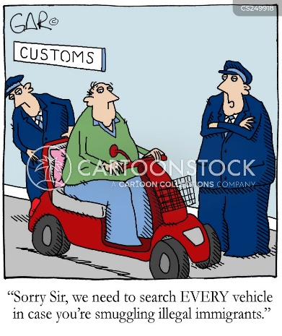
4.2. Watch the video and answer the questions:
https://www.youtube.com/watch?v=TjAni726S0Q
1) What is it about? Were your guesses correct?
2) What kind of load do the customs officers detect? Is it a prohibited or restricted item?

4.3. Watch again and answer the detailed questions. Key words from ex. 4.1. could help you.
1) Who are the passengers in the car?
2) Why were they in the US?
3) What questions do the customs officer ask the travellers?
4) What do the customs officers spot on the car?
5) Where do they find the load?
6) Why are the markings (numbers, a mouse) made on the packages?
7) What tool does a customs officer use to check if they have taken all the packages?
8) How many packages have they found?

4.4. Imagine that you have detected something illegal in the customer’s car. Role play the conversation between a customs officer and a customer with your partner.
Present your conversation in our lesson at 13.00.

5.1. Watch the video. What is it about? Which restricted or prohibited items are mentioned in the video?

https://www.youtube.com/watch?v=yCDnrPWqaa0 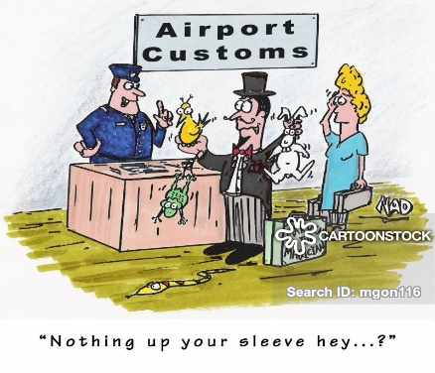

5.2. Complete the phrases with the words from the box:

counterfeit goods, traffickers, seizure, cash, wildlife, item, luggage, smugglers, goods, species.

1) Seize…
2) Weird ….
3) Inspect ….
4) Endangered ….
5) Counterfeit ….
6) Catch ….
7) Illegal ….
8) Drug ….
9) Forbidden ….
10) Human ….

5.3. Watch the video again and check.

6.1. Watch the video. What is it about?

https://www.youtube.com/watch?v=HSSA1WoZsmQ
6.2. Read the audio script of the video fill in the gaps with the words from the box:
Legitimate purposes, mission, the drugs, packages, details, Border Protection, vehicles, reasons, monitor drivers, smuggling, side panels, make sure, illegal substance, inspection, locate, hidden, scanned.

CBP officers work daily to secure ports of entry, checking people and vehicles

Several ports of entry line Arizona’s at southern border and that includes of course the Mariposa Port of Entry. And “9 on your side’s” Veronica Costa shows us the complex 1) ________when agents are on the front lines to stop drugs.

On a daily basis, the Mariposa Port of Entry is bustling not only with people, but also with 2) ___________. All subjects to an inspection from Customs and Border Protection officers.

“A very high percentage of people crossing the border are coming for 3) ______________. They are coming here to spend money, to pay taxes that support local businesses.”

But some are trying to get into the country for other reasons. 4) __________that involve drugs.

“We’re responsible to find those bad people”.

That’s where Customs and 5) _____________ officers come into play. Those officers tasked with being extremely vigilant and aware.

“Our officers really have like a sixth sense, you know, they really look for small, little 6) ________. Something wrong with the rear of the vehicle, the crossing pattern.”

CBP officers notice every vehicle. The closely 7) _________, keeping their eyes peeled for anything that could be off.

“He’s checking for admissibility, he’s checking for any kind of 8) ____________or contraband, and to ensure that that they are who they are.”

Now if the CBP officer feels there’s something off about the driver of a vehicle, or even the vehicle itself, well that’s when that person gets sent to second 9) ____________. This machine, called the Z portal, the first stop for those vehicles sent to secondary inspection. Vehicles are 10) _______ going through, any unusual items inside are quickly identified by officers. Then the canines move in doing their job to11) _________ there are no drugs stashed inside the car. If a canine or Z portal machine 12) ________ what seem to be drugs, that’s when officers come back in. Their job now – to take a closer look at what maybe 13) __________ inside.

“We want to ensure that that we verify and confirm that there is some type of the 14) __________ or contraband in a vehicle before we start to totally dismantle it.”

For officer Nunez finding drugs stashed inside car tires, dashboards or 15) _________ – nothing new.

“Every type of narcotics imaginable – heroine, cocaine, methamphetamines, fentanyl, illicit pharmaceuticals”

If they find any drugs during an inspection, they quickly go into this box, which allows officers to get a better idea of what the drug might be without actually exposing him or herself to it. This entire process happened while KGun 9 cameras were rolling, officers flagged the vehicle carrying multiple 16) __________later determined to be drugs. However, we cannot show you the video, because the case is still being prosecuted by the US Attorney’s Office. As for the driver of that vehicle and drivers in similar situations.

“It’s game over, I mean, literally for lack of a better term we own that car now.”

Busting 17) __________ in vehicles are part of the job for CBP officers, the job they do day in and day out. Veronica Costa, KGun 9 on your side.

And this Saturday KGun 9 will present the special “Securing the Arizona border a country divided”. You’ll hear from both Arizona senators as well as border sheriffs and ranchers, that’s coming up this Saturday afternoon at 4.00.

6.3. Watch the video again and check.

6.4. Read the audio script or watch the video again and answer the questions.

1) What Customs post is mentioned in the video?

2) What is the purpose of most people crossing the border at this border post?

3) What is the main Customs and Border Protection officer’s role?

4) What traits of character should a customs officer have to perform his duties well?

5) When are the vehicles sent to the second inspection?

6) What is the procedure of the second inspection?

7) What kind of drugs are mentioned in the video? Where are they usually hidden?

8) What happens to the driver when the drugs are detected in the vehicle?

7.1. Customs Equipment. Match the words (A-M) to the pieces of equipment
(1-13).

A plastic wedge | 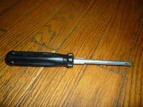 1 | H pliers | 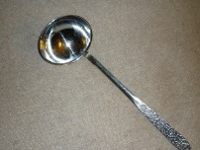 8
B tuck stick | 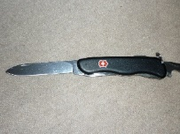 2 | I electric drill | 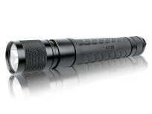 9
C screwdriver | 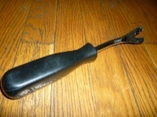 3 | J fibre optic | 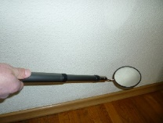 10
D mirror with telescopic rod | 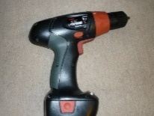 4 | K seal | 11
E flashlight | 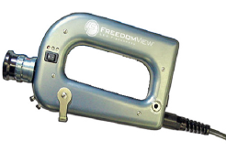 5 | L X-ray baggage scanner | 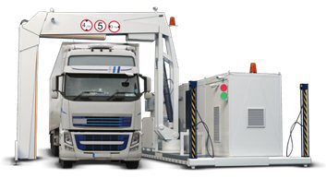 12
F knife | 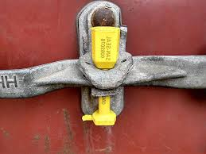 6 | M Vehicle and cargo X-ray scanner | 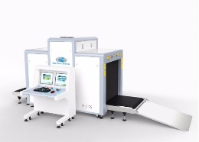 13
G scoop | 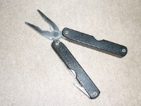 7

7.2. Choose 3 pieces of equipment and describe them to your groupmates to guess.

8.1. Life of a Customs sniffer dog.
Watch the video and answer the questions:

https://www.youtube.com/watch?v=qTp83HnWrL4

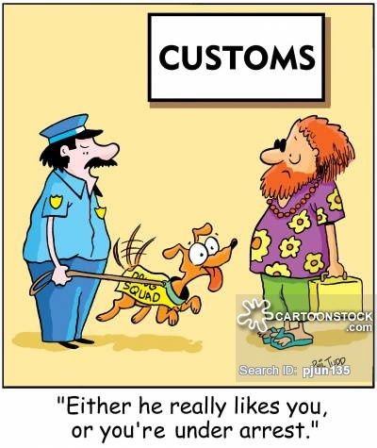

1. What is a sniffer dog? What does it do?
2. What functions of a sniffer dog are mentioned in the video?
3. Note down the key words from the video:

Smuggle all sort of stuff across the border
Make sure that illegal things don’t get into Europe
Work in rough conditions
Be good at detecting drugs/explosives/large amounts of cash
Trained to find forbidden food/ivory

8.2. Compare the functions of a sniffer dog in the video with the ones in your countries’ Customs. What is similar/different? Do you know anyone who has ever worked with a sniffer dog? Share your experiences.

9. Match the pictures (1-11) on the left to the descriptions (A-K) on the right.

Some of the Best Smuggling Tricks
1. | 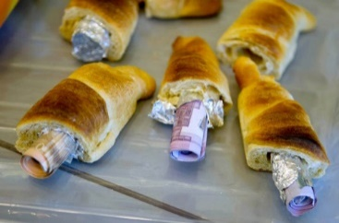 | A | Almost a metric tonne of marijuana in the shape of a donkey
2. | 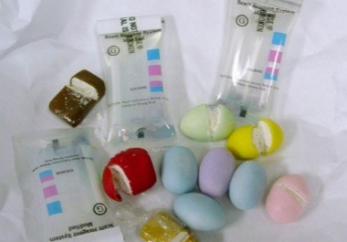 | B | Brick of methamphetamine covered in chocolate
3. | 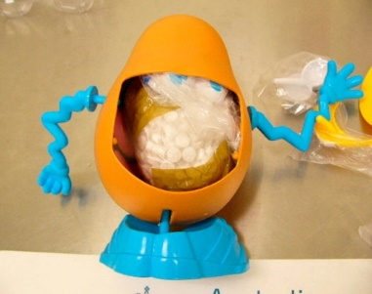 | C | Exotic frogs smuggled in camera film containers
4. | 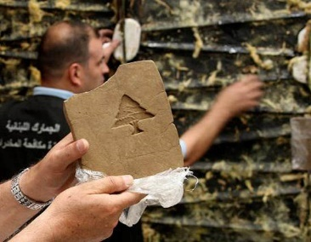 | D | 42 bottles of liquid ketamine, declared as holy water
5. | 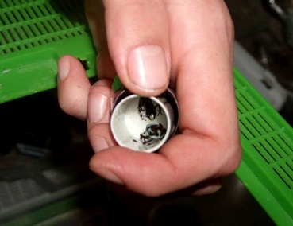 | E | Mr Potato Head toy containing 293 grams of ecstasy
6. | 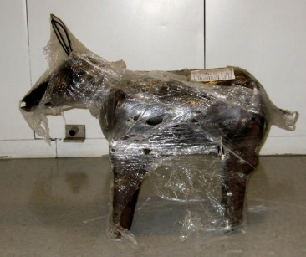 | F | Money smuggled in pastries.
7. | 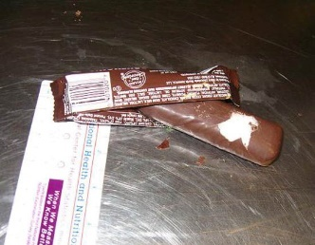 | G | Cocaine smuggled in Easter eggs.
8. | 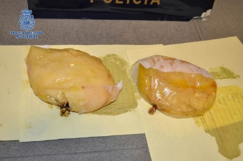 | H | Drugs mixed in crayons with an orange tint. This picture is sketched using those crayons (look the orange colour)
9. | 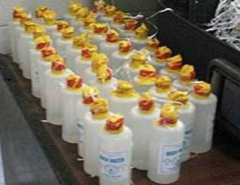 | I | 85kgs of bricks of hashish stamped with a Lebanese cedar
10. | 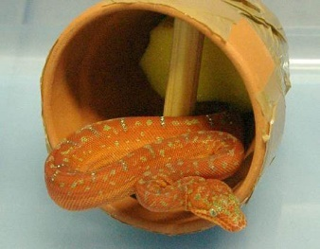 | J | Cocaine in breast implants
11. | 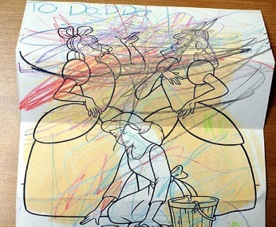 | K | Two snakes stuffed in clay pots

The pictures are taken from:
http://www.kickvick.com/smuggling-tricks/

10. Discuss some of the questions below in groups.
Tell some facts about your groupmates and share some of your ideas in our lesson at 15.00.

Questions for Discussion:

1) Did you search the cargo last week? Tell about it in details.
2) How many reports did you complete last month?
3) Have you calculated the value of goods this month? Give more details about that.
4) When did you last examine foreigner’s luggage? Give more details about that.
5) When did you last check the vehicle documents?
6) When did you last tell the traveller to pay a fine? Give more details about that.
7) When did you last ask the visitor to put his suitcase on the scales? Give more details about that.
8) When did you last ask the traveller to put his/her suitcase in the x-ray machine?
9) When did you last ask the traveller to show the permit? Give more details about that.
10) When did you last ask the visitor to unpack the box? Give more details about that.
11) When did you last seize traveller’s goods? Have you ever seized any weird goods? What were they?
12) Which equipment from Exercise 7 do you use at work? When and where do you use it?
13) When did you last detect contraband? Give more details about that.
14) What was the weirdest experience that you/your colleagues have ever had at work?
15) Share some smuggling cases from your or your colleagues working practice with the group. 16) Which restricted or prohibited items have you ever detained or seized?
17) Have you or your colleagues ever worked with a sniffer dog? Share your experiences.
18) What do you think of the quotation below? What are advantages and disadvantages of being a Customs officer?

“You couldn't pay me enough to be a law enforcement officer. Their job is a tough job. You have to solve people's problems, you have to baby-sit people, you have to always be doing this cat-and-mouse game with the bad guys. My respect for them is immense.” (Christopher Meloni)

11. Vocabulary for ALIAS game
n – noun; adj – adjective; v - verb
1 | 2 | 3
Excess n | Total adj | Pedigree n
Value n | Detain v | Cash n
Smuggler n | License n | Substance n
Vehicle n | Conditions n | Examine v
Duty free adj | Flashlight n | Allowance n
Seize v | Different adj | X-ray scanner n
Trafficker n | Locate v | Prohibited adj
Vaccination certificate n | Detect v | Legitimate adj
Border n | Mention v | Declare v
Restricted adj | Deal with v | Luggage n
Similar adj | Screwdriver n | Counterfeit goods n
Argue v | Inspection n | Load n
Sniffer dog n | Purpose n | Customs n
Traveller n | Scoop n | Suspicious adj

ANSWER KEY:

Ex. 1.2.
1- g); 2-i); 3-a); 4-h); 5-e); 6-j); 7-c); 8-d); 9-b); 10-f)

Ex. 3.1.
1-b); 2-f); 3-e); 4-c); 5-h); 6-a); 7-g); 8-d)

Ex. 3.2.
1) declare  2) presents  3) vaccination certificate  4) the pedigree  5) to examine | 6) value  7) total  8) duty free  9) allowance  10) in excess | 11) excise duty  12) turnover tax  13) no use arguing  14) will deal

Ex. 3.3.
1) Husband, wife and a dog.
2) Please declare the goods you’re carrying with you!
3) Cigarettes, spirits, presents. Restricted goods: cigarettes and alcohol.
4) Vaccination certificate.
5) They would have had to wait for the vet to examine their dog.
6) Yes, it is.
7) If you exceed the limited value of duty free goods, you will have to pay the duty.
8) Presents and spirits.
9) The tax on tobacco and the import turnover tax.
10) Value Added Tax.
11) Information about currency. Euros and cents should be used instead of French Francs (FF)/ marks/pfennigs.

Ex. 4.3.
1) Husband, wife and 3 kids.
2) To do some shopping for school supplies.
3) How long have you been in the US? Do you have arms or weapons?
4) Suspicious scratches.
5) Inside the car panel.
6) To distinguish where is it coming from and who is it going to?
7) Mirror
8) 26

Ex. 5.2.
1) Seize goods
2) Weird seizure
3) Inspect luggage
4) Endangered species
5) Counterfeit item
6) Catch counterfeit goods
7) Illegal cash
8) Drug smugglers
9) Forbidden wildlife
10) Human traffickers

Ex. 6.2.
1) mission  2) vehicles  3) legitimate  4) Reasons  5) Border Protection  6) details | 7) monitor drivers  8) smuggling  9) inspection  10) scanned  11) make sure  12) locate | 13) hidden  14) illegal substance  15) side panels  16) packages  17) the drugs

Ex. 6.4.

1) Mariposa Port of Entry.

2) Legitimate purpose – to spend money, to pay taxes.

3) To find bad people/ drug traffickers.

4) To be extremely vigilant and aware, to have the sixth sense.

5) If the officer feels there’s something off about the driver of a vehicle, or even the vehicle itself.

6) The Vehicle goes through Z portal machine, is scanned, the canine search the car. If the machine or the canine locate something, the officer takes a closer look at the vehicle.

7) Heroine, cocaine, methamphetamines, fentanyl, illicit pharmaceuticals. Tyres, dashboards, side panels.

8) It’s game over.

Ex. 7.1.

A-11; B-3; C-1; D-10; E-9; F-2; G-8; H-7; I-4; J-5; K-6; L-13; M-12

Ex. 9.
1-F; 2-G; 3-E; 4-I; 5-C; 6-A; 7-B; 8-J; 9-D; 10-K; 11-H

