BCP DIAGNOSTICS: PART II, 05.10.2021

Ex 1. Read the text The Reconstruction of San Ysidro Land Port of Entry: The Busiest Land Port in the Western Hemisphere and do the exrcises below.

The Reconstruction of San Ysidro Land Port of Entry: The Busiest Land Port in the Western Hemisphere

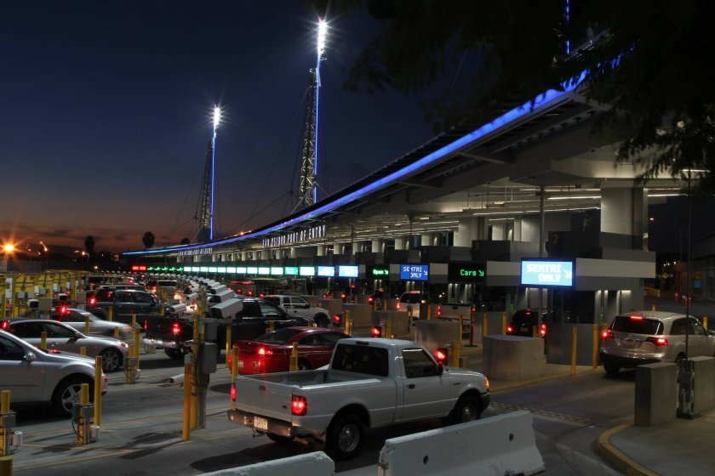

Located on the U.S.-Mexico border between San Diego and Tijuana, the San Ysidro Land Port of Entry (SYLPOE) is the busiest land port in the Western Hemisphere, processing eight percent of all people entering the United States.
The original San Ysidro crossing was designed in the 1970s and was unable (a) to keep up with the increase of travelers and the changes in security requirements. The crossing became so (b) congested that at one point, travelers faced wait times of three or four hours. That necessitated the reconstruction of the port.
In 2009, Miller Hull was selected by GSA (the General Services Administration branch of the US government) as the master plan and design architect to (c) update vehicle inspection procedures and reduce border wait times, while creating a more hospitable (d) gateway for people coming from Mexico and meeting (e) stringent security requirements. Working with Customs and Border Protection (CBP), Miller Hull developed effective new strategies for processing vehicles and pedestrians in a well-organized and secure environment.
Maintaining operations 24/7/365, the first construction phase was completed in 2014 amidst a congested and sometimes chaotic traffic environment. Its (f) focal point was the construction of the highly visible Port Operations Building. It consists of a head house, which allows officers to surveil the entire border crossing, built above ground level, and the renovated detention center, located underground. This architectural solution helps keep the majority of travelers moving through while holding those that need to be detained in a separate area.
Part of improving the wait times was accomplished by separating San Ysidro’s functions. While, after the overhaul, primary inspections still all happen under the main canopy, secondary inspections are separated out, directed into a different canopy so as not to impede the flow of travelers.
The 230-meter-long primary inspection canopy, which is is the (g) crown jewel of the San Ysidro renovation, (h) spans 35 lanes of inbound traffic. The canopy is 850 feet long and is supported at only four points by a combination of cables and masts. The construction team used an innovative product called ETFE (Ehtylene Tetrafluoroethylene) to achieve both cover and openness with the canopy and allow for a great deal of space for the officers to move about and do their jobs effectively.
Besides sheltering travelers from the sun, the canopy also provides relief for its officers from the heat and the toxic exhaust from idling cars. The light and translucent ETFE keeps the space well-lit, 24 hours every day, with a night-lighting system that bounces off the canopy. The canopy is also outfitted with an HVAC system that delivers a curtain of fresh air to cool the area down and offset the high CO2 levels from (i) idling vehicles. The breathing zones of vehicle inspection lanes and buildings are oriented away from CO2 emissions using a fresh air curtain around the officers, making the new facility a healthier place to work at.
Below the canopy, 62 inspection booths are stacked in tandem at each lane, allowing for the simultaneous examination of 2 vehicles at a time, which increases inspection processing time by 150 percent.
The inbound secondary inspection canopies are located to the west of the Port Operations Building, providing an inspection area for approximately 75 vehicles.
The crossing is also supplied with a (j) dedicated bus lane and a total of 36 pedestrian primary inspection lanes across its two pedestrian facilities.
In 2014, the subsequent phase of design and construction extended inbound inspection lanes and canopies and broadened the outbound operations of San Ysidro LPOE. Port operations were further expanded through the construction of outbound primary and secondary inspection canopies, an administrative Outbound Headhouse and parking garage. With a dual ramp configuration that (k) expedites traffic flow for employees and site personnel, the parking garage is the largest structure on site.
The new facility is designed to (l) accommodate an 87 percent increased vehicle capacity by 2030. And with improved flow of traffic, as well as better accommodations for staff operations, the current wait times at San Ysidro have already dropped to an average of 30 minutes.
By successfully redefining security, durability and performance, the new San Ysidro Land Port of Entry sets a modern standard for future border checkpoints across the United States and beyond.
Ex. 2. Say if the following statements are TRUE (T) or FALSE (F).
- The reconstruction of the San Ysidro LPOE was nessecitated because wait times at the port steadily increased over the years and the existing facilities could no longer accommodate the traffic volume.

- One of the primary objectives the main architect had to accomplish was the reduction of the border crossing wait times.

- During the first period of reconstruction, the port was closed for traffic.

- One solution for reducing the wait times for vehicles crossing the border was performing primary and secondary inspections at separate locations.

- The new primary inspection canopy provides shelter to the inspecting officers, but does not help much to reduce the exposure of the staff to harmful exhaust emisions.

- The secondary inspection area, constructed in the initial stage of the project can hold 75 vehicles at a time.
- During the second stage of the project, the infrastructure for processing traffic leaving the US was also improved.

- The largest structure of the renovated port of entry is the outbound secondary inspection facility.

- After the reconstruction, passengers have to wait only 30 minutes to be processed at the San Ysidro Port of Entry.
Ex. 3. Choose the correct meaning of the highlighted words/expressions from the text:
- a place through which you can go to reach another place | ___________________________
- to move or progress at the same rate as someone or something else | ___________________________
- a central point of attention or interest | ___________________________
- to make something happen more quickly | ___________________________
- modernize | ___________________________
- so crowded with traffic or people as to hinder or prevent freedom of movement | ___________________________
- strict, precise, and exacting | ___________________________
- vehicles the engine of which is running but the vehicles themselves are not moving | ___________________________
- the most important or valuable part of something | ___________________________
- to provide enough space or capacity | ___________________________
- a lane reserved only for processing buses | ___________________________
- extend across, to cover | ___________________________

Ex.4. Watch the video CBP Port of Entry Alcan, Alasca at https://www.youtube.com/watch?v=7RtNfa15wSA .

Ex. 5. Read the script of the video and fill in the blanks with words from the box:

- assessment, 2. integrity, 3. busy, 4. disease, 5. conduct, 6. through, 7. examined, 8. commitment, 9. threats, 10. dedicated, 11. paperwork

Truck drivers and travelers enter the United States from Canada (a)…………. the port of Alcan.
CBP officers (b)…………………….. operations just like at every other land port, but at Alcan they must do so in extreme conditions during the winter months.
Passengers and cargo must be (c)……………………. and (d)………….. checked and collected even when temperatures fall to seventy degrees below zero.
‘In order to work at Alcan first of all you have to have the desire to be here, to experience the extremes – the cold, the very slow winter periods, the very (e)……………….. summer periods, having to drive three or four hundred miles to get your food. You have to have a (f)…………………….. to the job in order to put yourself in that situation and still maintain the utmost level of (g)……………………… and determination, and hard work. These guys here are the most commited people I’ve ever met – very (h)………………………. and very good officers’, says Jahnie Kehler, Port Director of Alcan port of Entry.
Travellers could be unknowingly transporting a pest (i)………………… or pathogen. An insect inside a piece of fruit or an invisible disease on the sole of a shoe could become a great danger to the US food supply.
By asking just a few questions, the CBP agriculture specialist can determine if a traveler could possibly be bringing the deadly Food-and-Mouth disease into the United Sates on a pair of work boots worn on a farm in Canada and subject the suspect boots to disinfection with a special cleaning solution.
Cleaning a pair of boots is a small price to pay for protecting the US food supply, farms, wildlife and citizens. CBP Agriculture Specialists maintain a frontline defense against (j)……………… to American agriculture.
As with all ports of entry accurate (k)………………… of travelers mean the difference between allowing legal trade and travel into the US and keeping illegal and dangerous people and goods out.
Field operations officers at Alcan Port of Entry continue to keep US northernmost border safe and secure.

Ex. 6. Watch the video CBP Port of Entry Alcan, Alasca and check your answers.

Ex. 7. Match the words with their meanings:

- assessment | - inspect (v)
- integrity | - carry out (v)
- busy | - the documentation accompanying a shipment or a person
- disease | - the quality of being honest and having strong moral principles
- conduct (v) | - dedication
- examine (v) | - the process of considering all the information about a situation or a person and making a judgement
- commitment | - the possibility that something unwanted will happen
- threat | - (an) illness of people, animals, plants, etc., caused by infection
- dedicated | - full of activity
- paperwork | - devoted to a perticular purpose or job

Ex. 8. Form the negatives of the words below:

+ | -
allow
lawful
authorized
prohibited
legitimate
licit
compliant
legal

Ex. 9. Watch the video Customs Officers Inspect Vehicles at Nogales Port of Entry at https://www.youtube.com/watch?v=LmCRCYTzC40
Work in groups of 4. Describe what you have seen. Answer the questions:
- What types of inspections are shown in the video?
- What tools did the customs officers use?
- What items of infrastructute could you distinguish?

Ex. 10. Check the odd one out:
a/ customs officer, customs official, customs inspector, forwarding agent
b/inspection, interview, exam, check
c/ empower, revoke , authorize, entitle,
d/ lorry, truck, heavy-goods vehicle (HGV), passenger car
e/ equipment, gear, screwdriver, technology, outfit

Ex. 11. Read the text about Kapitan Andreevo BCP

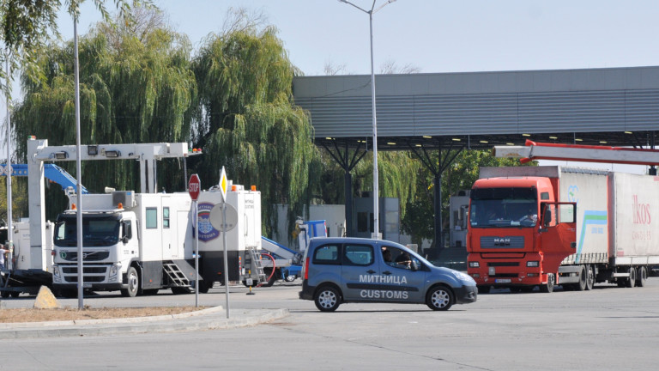
Kapitan Andreevo BCP
Kapitan Andreevo is a land border crossing point located on the EU external border with Turkey. With a throughput capacity of about 2000 freight trucks and 3000 passenger vehicles a day, it is the busiest land border checkpoint in Europe and the second largest one in the world, after San Ysidro Land Port of Entry, USA.
Layout and Infrastructure
Kapitan Andreevo BCP is designed and organized in such a way, as to accommodate a vast volume of traffic, expedite the traffic flow and provide a swift control process by streamlining the inspection procedures and applying the necessary measures to facilitate legitimate trade and focus attention to transactions that pose a risk.
There are separate control terminals for trucks and traveler vehicles, which are further subdivided into segregated inbound and outbound traffic areas.
The inbound customs control area is organized in 10 separate truck-inspection lanes. Each lane is equipped with a weighbridge, documentary control booth, ANPR - system, CCTV – cameras and traffic lights and a barrier for managing the movement of trucks. Overhead signage directs the drivers to the appropriate processing lanes, according to the type of customs document the cargo is hauled under. Three of the lanes are dedicated for processing perishable produce, such as meat, fruit and vegetables in temperature-controlled conveyances. One of the lanes is specially designed for handling oversized vehicle-cargo compositions. A metal shed structure covers the 10 booths providing a comfortable working space for the customs inspectors, who perform their duties outdoors and conduct the primary visual checks of the vehicles. Detailed cargo examinations are carried out in freight inspection sheds, fitted with truck inspection pits and gantries, forklift trucks, pallet scales and scanners and truck dismantling gear.
There are two X-ray cargo scanners at Kapitan Andreevo (one stationary drive-through X-ray machine and one mobile container/vehicle inspection system), both positioned in the Non-Intrusive Inspections site in the inbound truck-inspection zone.
Trucks leaving the EU are processed in the outbound freight terminal, organized in a similar way. It comprises 6 truck-processing lanes, with a fast lane for perishable goods and animal transports. A metal shade structure spans the 6 lanes.
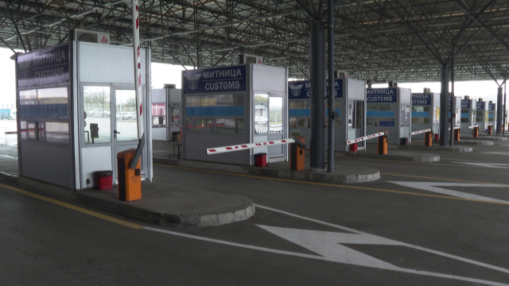
The passenger processing area is divided into inbound and outbound terminals, with 10 lanes for cars and buses entering the EU, including a dedicated bus lane, and 7 lanes for passenger vehicles leaving it. There is not a segregated pedestrian passage area for people crossing the border on foot, since their number is limited.
There is a thorough inspection shed in the inbound car inspection zone, outfitted with 2 vehicle inspection pits, a relocatable baggage x-ray scanner, a vehicle lift and other essential gear.
Warehouses are provided for the storage of seized goods. However, there is not an impound lot and seized vehicles are parked in the buffer areas following the line of customs control while in the custody of the customs authorities.
The administrative building is the place where shift leaders hold the briefings with the staff in the beginning of a shift and other administrative activities are carried out.
There are two remote customs control booths, where the formalities for trucks carrying foodstuff and animals, having passed through veterinary and phytosanitary control are completed.
Workflow: Trucks Entering the Customs Territory of the European Union
Before entering the territory of the EU a freight vehicle passes through a radiation portal monitor (RPM), designed to capture traces of radioactive materials. After that it is sanitized by driving through a disinfection gate. Then the truck proceeds to the Border Police inspection area, where Border Guards perform the types of controls entrusted to their administration.
Following that, the lorry approaches the line of customs control through a buffer parking lot, where trucks line up in wait to be invited to proceed to the customs documentary control booth. When he is ready the customs inspector signals to the driver to proceed, by means of traffic lights. While the truck approaches the control booth, it passes through a loop that activates the ANPR-system and OCR-cameras capture its front and rear registration numbers and transmit this information, together with stored images of the number plates (license plates) to the customs control software. En route to the documentary control station the vehicle also passes though dynamic axle scales that establish the weight of each single axle and stops at a weighbridge, were its total weight is measured. The information of the weight control is automatically registered in the customs control application. At the documentary control stage, a customs inspector carries out the formalities for vehicles entering the customs territory of the EU and verifies the information in the customs documents. This is where he conducts the first stage of risk analysis by comparing the weight of the truck and cargo registered by the vehicle weighing equipment and the declared weight of the consignment. If anything raises the suspicion of the customs official, he may select the vehicle for further examination and direct it to the Non-intrusive inspection site, where it will be scanned, or to the detailed inspection shed, where it can be offloaded and thoroughly inspected.
The initial visual check of a truck is performed directly under the metal canopy, or in close proximity to the documentary control booth. If alerted, the customs inspector, responsible for the physical inspection of the vehicle can also subject it to further control procedures. After all control procedures have been carried out, the customs officer, responsible for paperwork processing registers the results in the customs control software and the truck is released to exit the customs post. The final stop is a booth at the exit of the BCP, where a customs officer checks whether the vehivle has undergone all necessary control procedures and If satisfied with the results, allows it to enter the Customs territory of the EU.
Vehicles carrying food, fruits or vegetables, animals or meat, that have to undergo veterinary and phytosanitary inspection are directed to the respective facilities. After completing the formalities at the veterinary and phytosanitary border posts, these trucks proceed to the remote customs working stations where they are sealed and released for transit.
In the majority of cases, the customs authorities at Kapitan Andreevo carry out the formalities for goods under the EU transit procedure. Formalities for the other customs procedures are normally carried out at inland customs posts.

Ex. 12. Match the acronyms with their meanings:
- ANPR | - Optical Character Recognition /  Optical Character Reader
- OCR | - Radiatiom Portal Monitors
- LPR | - Vehicle and Cargo/Container Inspection System
- VACIS | - Automatic Number-Plate Recognition
- RPMs | - License Plate Recognition

Ex. 13. Prepare a similar presentation of the BCP you work at and share it with us.
Time limit: 3 minutes

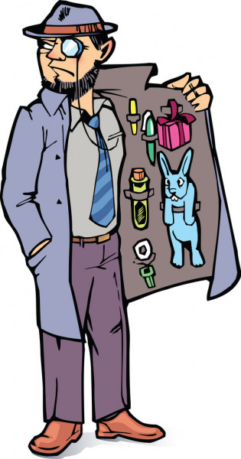
Ex. 14. Watch the video 10 Smartest Smugglers in All History at https://www.youtube.com/watch?v=khnfsHNxDBk.
and say if the following statements are TRUE (T) or FALSE (F). In case a statement is true, write down the exact words the narrator says. In case they are false, write down the correct phrase/sentence:

Case 1: Cigarettes in tree trunks: 0:34 – 1:37
- The perpetrators smuggled the cigarettes by rail ……………………………………………………………………………………
- They used packages hidden amongst the trunks to smuggle the contranand.
…………………………………………………………………………………………
Case 2: Gold in a shirt : 1:38 - 2:18
- The two smugglers tried to carry the gold illegally across the border by road.
…………………………………………………………………………………………
- They concealed the gold in their clothes.
…………………………………………………………………………………………
- In total the customs officers seized 2.5 kilograms of pure gold from the smugglers.
…………………………………………………………………………………………
Case 3: A Model Family: 2:19 - 3:14
- Even upon first sight the family, their car and attire raise the suspicion of customs officers.
…………………………………………………………………………………………
- Even observing a few scratches might make a customs officer conduct a thorough inspection of a vehicle.
…………………………………………………………………………………………
- The customs ofiicers had to dismantle the car completely to find the contraband.
…………………………………………………………………………………………
Case 4: Drone Smugglers: 3:15-4:16
- Drones were used to smuggle prohibited items across land borders.
…………………………………………………………………………………………

- The advantages of drones as smuggling tools are their low cost, and easy operation and elusiveness.
…………………………………………………………………………………………

Case 5: Reptiles on the Body (4:17- 5:05)
- In the first case customs officers intecepted a man who tried to smuggle 14 pythons and 10 gekhos, as well as a tarantula across the border.
…………………………………………………………………………………………
- The officers decided to search the smuggler after they noticed a tarantula running quickly around in one of his bags.
…………………………………………………………………………………………

Case 6: The Shawshank Redemption (5:06- 6:15)
- This is a story picturing a traditional cross-border smuggling attempt.
…………………………………………………………………………………………
- The watchful security officers working at the prison busted Maria’s plan.
…………………………………………………………………………………………
- The unusual shape and size of the suitcase and the nervous behaviour of the woman alerted the prison guards. …………………………………………………………………………………………
Case 7: A Man inside a Car Seat (6:16 – 7:23)
- The story took place at the border between the United States and Canada.
…………………………………………………………………………………………
- The man hid himself in the trunk of a car in an attempt to cross the border illegally.
…………………………………………………………………………………………
Case 8: 94 iPhones: (7:24 – 8:21 )
- The man tried to cross the Chinese border with a nag full of 94 iPhones.
………………………………………………………………………………………
- What betrayed the smuggler was his strange way of walking.
………………………………………………………………………………………
- The wary customs officers found some contraband in the man’s hand luggage too.
………………………………………………………………………………………

- The smuggler was also subjected to a metal detector scan, which indicated the presence of hidden contraband.
…………………………………………………………………………………………
Case 9: Hummingbirds in Pants (8:22 – 9:23 )
- The customs officials observed the man’s strange behaviour and detained him.
………………………………………………………………………………………….
- This was the first attempt of the man to smuggle tiny anymals across the border.
…………………………………………………………………………………………

Case 10: A Truckload of Ammo (9:24 – 10:39 )
- In Brownsville, Texas, stolen automobiles are often utilized as a means of illegal transportation of goods across the border.
…………………………………………………………………………………………
- Special units perform detailed checks on vehicles meant for exportation to reveal cases of intended smuggling.
…………………………………………………………………………………………
- The officers noticed that the tailgate of the truck had been manipulated
…………………………………………………………………………………………

Ex. 15: Watch the video again and find the exact words that mean:
Introduction: (0:00 – 0:33)
offenders, violators: | ____________________
original, creative: | ____________________
Case 1: Cigarettes in tree trunks: (0:34 – 1:37)
- customs inspection: | ____________________
- unveil: | ____________________
Case 2: Gold in a shirt : (1:38 - 2:18)
- a person who knowingly helps another in a crime or wrongdoing: | __________________
- seized: | ____________________
Case 3: A Model Family: (2:19 - 3:14)
- intensive examination: | ____________________
- too ambitious, enthusiastic and eager: | ____________________
- intuitive feeling, suspicion: | ____________________
Case 4: Drone Smugglers: (3:15-4:16)
- developing: | ____________________
- small ingenious mechanical or electronic device: | ____________________
- violation: | ____________________

Case 5: Reptiles on the Body (4:17- 5:05)
- to keep from happening: | ____________________
- transferred: | ____________________
Case 6: The Shawshank Redemption (5:06- 6:15)
- held in custody: | ____________________
- betrayed: | ____________________
Case 7: A Man inside a Car Seat (6:16 – 7:23)
- emptied of its contents: | ____________________
Case 8: 94 iPhones: (7:24 – 8:21 )
- the newest or most recent: | ____________________
- strange: | ____________________
- careful and observant | _____________________

Case 9: Hummingbirds in Pants (8:22 – 9:23 )
- the government officials: | ____________________
- examination: | ____________________
Case 10: A Truckload of Ammo (9:24 – 10:39 )
- illicit: | ____________________
- not matching with, out of place: | ____________________

Ex. 16. Read the text. Match the highlighted words with their meaning.

Border Patrol Agent’s Hunch Pays off in Second-LargestMetamphetamine Bust Ever.
A suspicious U.S. Customs and Border Protection agent, who decided (1) extra scrutiny was needed for a truck that was supposed to contain a (2) shipment of medical supplies, was responsible for discovering more than 3,100 pounds of methamphetamine, fentanyl and other illegal substances – the second-largest ever (3) bust of its kind along the southwest American border. The drugs, which were discovered at the Otay Mesa Port of Entry, in San Diego, were found in a truck that pulled into the (4) commercial side of the border crossing.
CPB officers, using the port’s (5) imaging system, found suspicious materials in the rear of the trailer. The trailer was sent to the dock and a (6) canine alerted them to the boxes inside.The shipment was unloaded before CPB discovered 1,816 packages (7) co-mingled with the medical supplies. Included in the haul was approximately 3,014 pounds of methamphetamine, 64 pounds of heroin, 29 pounds of fentanyl powder and almost 37 pounds of fentanyl pills, worth an estimated $7.2 million.
“This massive seizure is testament of what law enforcement agencies can do when we combine forces — prevent over $7 million worth of deadly drugs from entering our country, thus saving countless lives from addiction and overdose deaths,” said DEA Special Agent in Charge John W. Callery.
The driver, a 47-year-old Mexican citizen, was arrested, the report said.
“This significant seizure is a prime example of how a successful partnership between HSI, CBP and DEA results in the (8) disruption of transnational criminal organizations while protecting our country from dangerous illicit drugs,” said Juan Munoz, acting Special Agent in Charge of HSI in San Diego.

- the area where vehicles carrying goods for reward are processed
- a large amount of goods sent together to a place, or the act of sending them:
- mixed together with
- additional checks
- a non-intrusive vehicle scanning system
- a seizure of illegal drugs by the customs authorities

- delaying, diverting or otherwise complicating the commission of crimes
- a dog

Ex. 17. Watch the video CBP Officers Use the CSECO Fiberscope during Routine Vehicle Inspections at https://www.youtube.com/watch?v=z0YjzUVLqRk and do the tasks below:
Task 1: Answer the questions:
- Which Port of Entry does the video feature?
- Why the customs officers initially stopped the pick-up truck?
- What raised the suspicion of the customs officers?
- What was the purpose of the canine team inspection?
- What was the result of the K9-exam?
- Where did the customs officer at the secondary inspection site think the drugs had been hidden?
- What equipment did he use to find the contraband?
- What did he see with the help of this device?
- What are the next stages of inspection?
- What did the inspection team find stashed in the tank? What were the subsequent actions of the customs officers? –
- What was the type, amount, and weight of the smuggled substance What will happen to the seized drugs?

Ex.18. Read the text describing the hiding places used by smugglers and make a list of all synonyms that mean ‘a secret compartment’.
Traffickers can smuggle drugs in numerous ways. Human couriers move drugs by concealing them with their bodies either by hiding them in or under their clothing or by inserting or ingesting them into their persons. Some traffickers use go-fast boats or small planes to smuggle drugs into the country. Others simply ship the drugs in parcels via the postal service or retail shippers and hope law enforcement will not interdict the packages. Another popular technique is to store the drugs within a hidden or concealed compartment in a vehicle. These compartments, also known as hides, traps, or clavos, are designed to disguise their existence by blending into the normal elements found in many means of transportation, such as cars, trucks, vans, boats, or airplanes. Such compartments can be built into almost any part of a vehicle, including seats, gas tanks, trunks, spare tires, and dashboards.
Hidden compartments can vary in size and complexity. Some are designed to hold a single handgun while others can contain hundreds of pounds of drugs. In addition, the sophistication of a hide is only limited by the creativity and technical knowledge of its designer or installer. Rudimentary secret compartments consist of a very basic design with little or no alteration of the vehicle. Examples include using the space behind the center of the steering wheel or cutting away part of the rear bumper and adding a lid with hinges. More elaborate stash compartments appear as part of the vehicle to inhibit the ability of law enforcement to discover them. Upon a cursory or even thorough examination, officers may overlook the concealed compartment because of its disguise as an unaltered component of the vehicle. However, the actual compartment is covered by a lid or built as a drawer. The lid or drawer is powered open by an electronic or pneumatic motor that can be triggered by activating a complex series of switches, such as turn signals, power windows, or the defroster. Beyond the difficulty of actually detecting the hide, officers often cannot determine the proper series of switches needed to open it. This provides an added level of protection for the illegal contents hidden inside the compartment. There are a lot of people who install false compartments in vehicles that are definitely difficult to locate — even when using an X-ray machine.
……………………………………………………………………..
……………………………………………………………………..
……………………………………………………………………..
……………………………………………………………………..
……………………………………………………………………..
……………………………………………………………………..
……………………………………………………………………..
……………………………………………………………………..
……………………………………………………………………..
……………………………………………………………………..
Ex. 19. Read the two sentences and decide in which sentence the word ‘stash’ means:
a/ an amount of something that has been stored or hidden
b/ to store or hide something

- The customs officers discovered a stash of money hidden in a secret compartment in the trunk of the car.

- The narcotics were stashed under the driver’s seat of a Dodge Ram truck..
Ex. 20. Watch the video The Unexpected Smuggler at https://www.youtube.com/watch?v=mdneb2bqM1Y
and choose the correct answer to the questions below:

- At 8:15 officer Laurence Gardea:
a/ searches pedestrians entering the US with his canine partner
b/ searches queuing vehicles with his canine partner
- The vehicle was selected for further checks because:

a/ the drug-detecttion dog raised an alarm
b/ the driver of the vehicle behaved aggressively

- On first impression, the driver of the vehicle was:
a/ an unlikely suspect
b/ a very suspicious figure
- According to the driver’s story, the purpose of her visit to Mexico was:
a/ buying groceries
b/ visiting her brother
- The check with the density meter produced:
a/ abnormal readings
b/ normal results
- After getting the abnormal readings from the Buster device:
a/ the customs officers handed over the vehicle to the police for further inspection
b/ directed the vehicle to the secondary inspection area where they perform a detailed check at the place of the alert
- Secondary vehicle inspection was conducted:
a/ in a secure area at the port of entry
b/ at an inspection bay adjacent to the primary traffic lanes
- What is the purpose of the fence and gates at the secondary inspection area:
a/ to protect the vehicle from stealing
b/ to prevent cartel members and others from looking on
- What clue did the officer find behind the car’s stereo?
a/ a sign of manipilation – a non-factory tape
b/ scratches and new paint
- According to the inspecting officers, what was the old woman smuggling?
a/ cocain
b/ marijuana

Ex. 21. Speaking!!! Work in groups of four. Tell your group-mates about the most remarkable seizure you have made in your career as a customs officer. Take turns.
Answer these questions:
- When did it happen?
- Which BCP were you performing your duties at at that time?
- What was the type of conveyance used to transport the item/substance across the border?
- Where was the illegal object hidden?
- What type of inspection method was employed to reveal it?
- What was the smuggled item?
- Was there a need of any additional tests? What were they? What did they show?

Types of Vehicles

Ex. 22. Match the vehicles from the pictures below with the words describing the respective vehicle type.

- curtain sided trailers /also known by the generic names of tautliners or custainsiders;
- sheeted trailer /tarpaulin trailer/tilt trailer;
- refrigerated/reefers/chiller trailers/fridge trailers/temperature-controlled trailers;
- car-carriers, car-transporters, vehicle-carriers;
- container – carrier;
- box-trailer;
- flatbed trailer;
- tanker;
- tank-tainer;
- livestock trailer;
- tractor unit/prime mover;
- van;
- low-loader;
- cement trailer/cement bulker/ cement silo trailer/ cement tanker.

a/  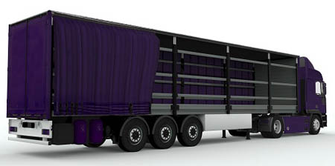 | b/  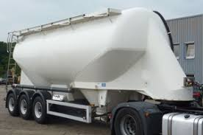
c/  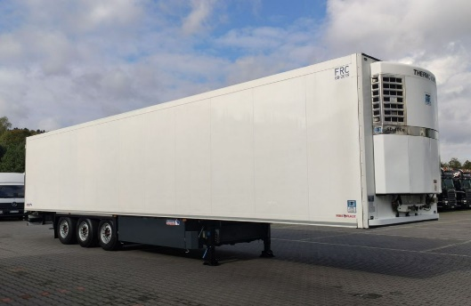 | d/  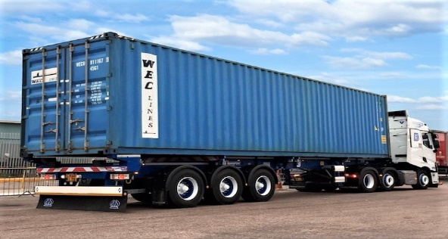
e/  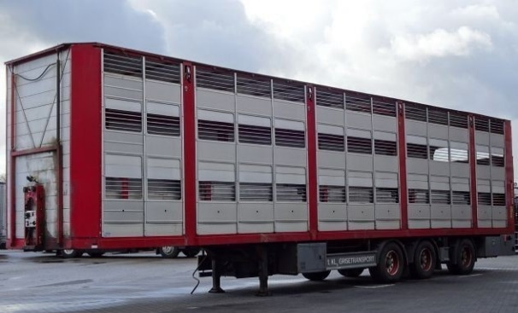 | f/  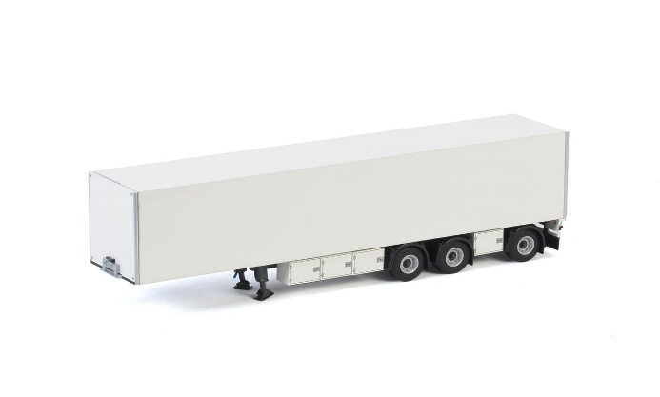
g/  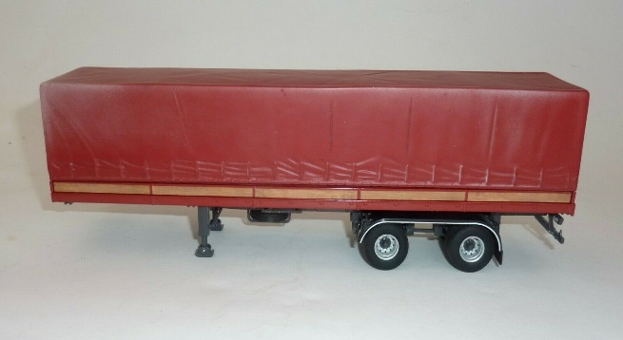 | h/  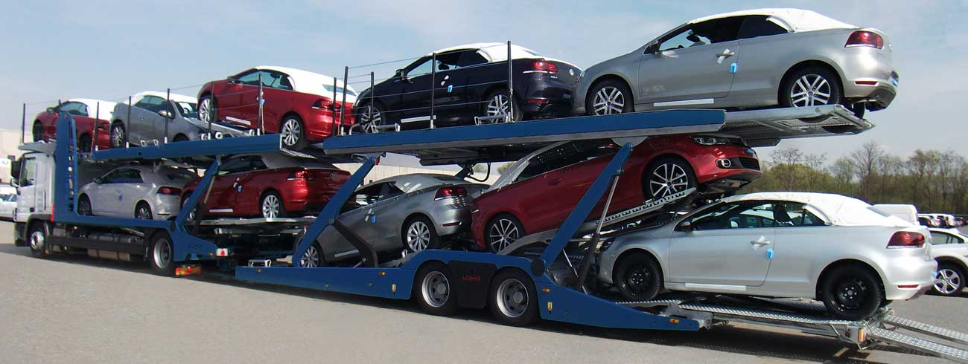
i/  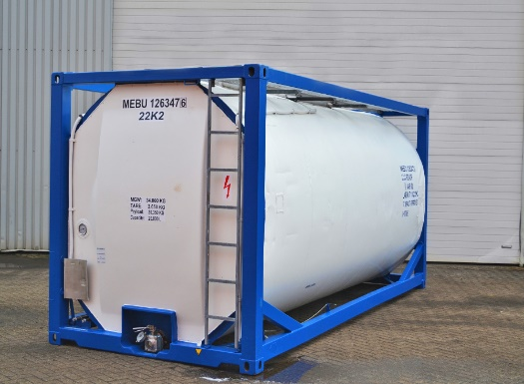 | j/  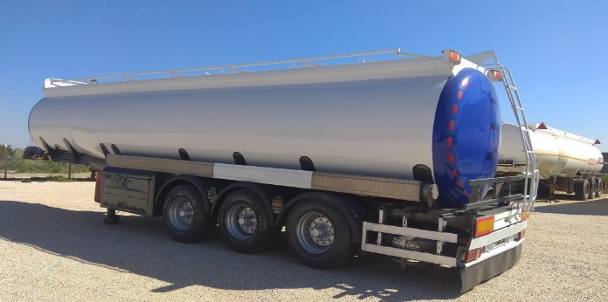
k/  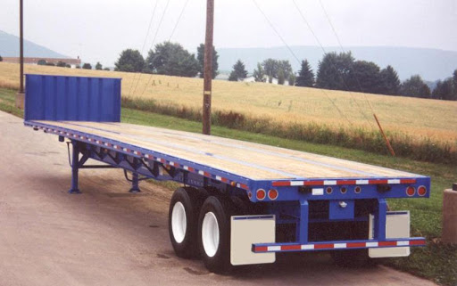 | l/  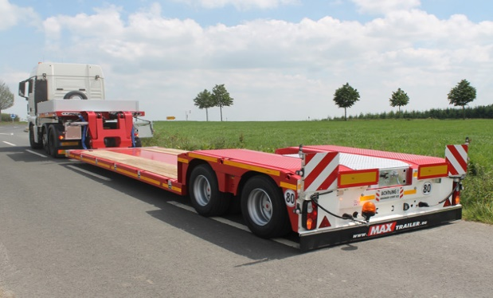
m/  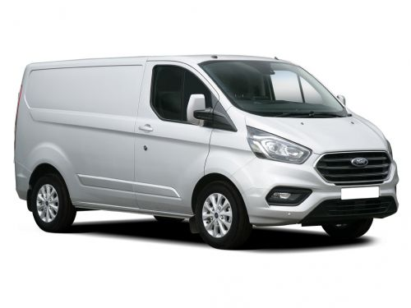 | n/  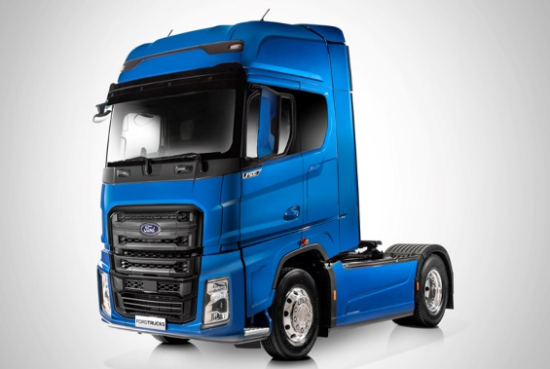

Ex. 23. Read the gapped text and fill in the blanks with words from the box:

- conduct, (2) confidence, (3) non-instrusive, (4) facility, (5) jointly, (5) advance, (6) unencumbered, (7) released, (8) targeted, (9) conjunction, (10) boost

Unified Cargo Processing

Unified cargo processing, also known as UCP, is a concept that was spearheaded out of Arizona. The concept has Mexican Customs Officers working side by side with U.S. Customs officers on the United States side to (A)………………….inspect and process shipments of cargo destined for the United States. We initially started with the inbound to the United States and later expanded it to outbound cargo into Mexico.
The concept was immediately embraced by Trade. They’ve seen a reduction in transaction costs from their shipments from Mexico into the United States
as well as the United States back into Mexico.
This prototype is, without a doubt, a very important project. It benefits the user directly by time and cost savings. It recognizes the users in whom we have more (B)……………….., more interaction among our international trade operations, that is to say, those companies certified under CT-PAT or under NEEC. We’ve demonstrated solid benefits for our users in the short period of time that it has been implemented.
First, since the program initiated in Nogales, we have a reported time savings of close to three hours. On the other hand, we have initiated the project in Agua Prieta and have also seen important time savings.
If we continue replicating this initiative, this project in different Ports of Entry, we will have more benefits to strengthen and consolidate the trade exchange between both countries.
Prior to cargo destined to the United States arriving at the border, both CBP and SAT receive (C)…………………….information from the trade about the shipment. This information is reviewed to ensure there are no merchandise admissibility issues. Upon approaching the border, non UCP shipments are directed into the SAT (D)………………………to be processedand possibly examined.
However, UCP shipments bypass the SAT facility and enter a dedicated lane that allows the shipment to proceed (E)……………………….to CBP primary. While at primary, CBP and SAT officials review the appropriate documentation and determine if the shipment may proceed into the commerce of the United States or if further examination is necessary. If no issues exist, the driver and truck are (F) ………………….and the commodity is allowed to enter the commerce of the United States and is ready for sale or use by the importer.
In the event that an issue is discovered, the shipment is sent for a secondary examination. CBP and SAT (G)……………………… joint inspections of all UCP shipments that have been targeted for examination.
By conducting joint inspections, UCP eliminates the possibility of a shipment being inspected twice and allows for all issues to be resolved at a single point. Once the examination is completed, the merchandise is released into the commerce of the United States for consumption as long as no law enforcement actions such as seizure or detention are required.
For cargo destined to Mexico, information regarding the shipment arriving at the border is sent electronically in advance to CBP and SAT.
Upon arriving at the dedicated outhbound UCP primary booth, the driver presents all the relevant documentation to the CBP and SAT officials. If there are no concerns during a review of the documentationthe shipment may proceed into Mexico.
Upon entering Mexico, the shipment bypasses the SAT import facility and proceeds to a dedicated (H)……………………. inspection site where it is x-rayed and then released into the commerce of Mexico.

A shipment destined for Mexico that is (I)………………….. for examination is referred to the Secondary inspection site at the U.S. port of entry. During the Secondary inspection, CBP and SAT work together to address any law enforcement concerns, trade compliance or other issues prior to allowing the merchandise to proceed into Mexico.
Another aspect of UCP is Rail operations Rail shipments are inspected by CBP in (J)………………………..with SAT Officials as they enter and exit the U.S.
Any needed inspections are completed by both agencies in one examination. If no issues exist the merchandise is released either into Mexico or into the United States.
Unified Cargo Processing, UCP, was started in Nogales at the Mariposa Port of Entry. The concept was rolled out to the Douglas Port of Entry and also to the San Luis Port of Entry. There is a push to expand the same process to other ports of entry along the Mexico/ U.S. border.
The final objective of this model is, without doubt, to (K) ……………….. international trade. But also, it is our responsibility to work towards national security. The objective of any customs administration is to achieve legal trade, a trade that is agile and that incentivizes the economies, but we also achieve the central point of our obligation, that is to protect our borders, protect our countries and achieve the national security required by our Nations.

Abbreviations, used in the text:
SAT - Servicio de Administración Tributaria / Mexican Tax Administration Service's
CBP – Customs and Border Protection, U.S.A

Ex.24. Watch the video Unified Cargo Processing and check your answers.

The video is accessible from the following link:
https://www.cbp.gov/newsroom/video-gallery/video-library/unified-cargo-processing-ucp

Ex. 25. Say if the following statements are TRUE (T) or False (F):
- U.S. and Mexican customs authorities work jointly on the Mexican side of the border.
- Representatives of the business sector like the idea very much.
- After the launch of the project wait times were reportedly reduced by 3 hours.
- When UCP shipments, destined for the USA, reach the border, they are subjected to an inspection by SAT after which they are directed to the BCP primary examiation area.
- If a vehicle is selected for secondary inspection in the US inbound control area, CBP and SAT customs officers carry the further checks jointly.
- If a consignment, intended to be imported into Mexico, is shortlisted for secondary inspection, the respective examination activities are carried out on Mexican territory.
- Rail shipments can benefit from the UCP project only if they are intended for import into the U.S.A.

Ex. 26: Work in groups. Brainstorm the topic THE LAND BORDER CROSSING POINT OF THE FUTURE. Nominate a speaker of the group who will present the ideas of the group in the main room

WHAT IS YOUR IDEA OF THE BCP OF THE FUTURE?
Give as many suggestions as you can. These questions might help you:
- What will be its ideal layout?
- What items of infrastructure will it include?
- What types of control measures will be carried out?
- What measures will have to be taken to expedite the traffic flow?
- What technologies will be employed in the process of customs control?
- How will threats be managed?
- How will the interaction and cooperation between the different agencies, operating within the BCP be organized?

Answer Key:

Ex. 2: 1 – T, 2 - T, 3 - F, 4 - T, 5 – F , 6 – T, 7 – T, 8 – F, 9 – T
Ex. 3: 1-d, 2-a, 3-f, 4-k, 5-c, 6-b, 7-e, 8-i, 9- g, 10-l, 11-j, 12-h
Ex. 5: a - 6, b - 5, c - 7, d - 11, e - 3, f - 8, g - 2, h -10, i - 4, j - 9, k - 1
Ex. 7: 1 - f, 2 - d, 3 - i, 4 - h, 5 – b, 6 – a, 7 – e, 8 – g, 9 – j, 10 -c
Ex. 8
+ | -
allow | disallow
lawful | unlawful
authorized | unauthorized
prohibited | non-prohibited
legitimate | illegitimate
licit | illicit
compliant | non-compliant
legal | illegal

Ex.10.
a - forwarding agent, b – interview, c – revoke, d - passenger car, e – screwdriver
Ex. 12: 1– d, 2 – a, 3 – e, 4 - c, 5 -b
Ex 14.
Case 1: 1 –T, 2 –F , Case 2: 1- F, 2-T, 3-T, Case 3: 1 – F, 2 –T, 3 - T, Case 4: 1-F, 2-T, Case 5: 1-T, 2-T, Case 6: 1-F, 2-T, 3 –T, Case 7: 1 F-, 2 – F, Case 8: 1 – T, 2-T, 3-F, 4-T, Case 9: 1-T, 2-F, Case 10: 1 – T, 2 – T, 3 – T
Ex. 15:
Introduction: perpetrators, ingenious, Case 1: customs check, uncover, Case 2: accomplice, confiscated, Case 3: detailed examination, overzealous, hunch, Case 4: evolving, gadget, fraudulent actions/offence, Case 5: prevent, handed over, Case 6: detained/arrested, gave herself away, Case 7: hollowed out, Case 8: the latest, weird, vigilant, Case 9: the authorities, inspection, Case 10: illegal, inconsistent with
Ex. 16: 1 – d, 2 – b, 3 – f, 4 – a, 5 – e, 6 – h, 7 – c, 8 – g
Ex. 18. hidden or concealed compartment, trap, clavo, hide, secret compartment, stash compartment, false compartment, concealed compartment
Ex. 19. 1 – b, 2 – a
Ex. 20. 1 – b, 2 – a, 3 – a, 4 – b, 5 – a, 6 – b, 7 – a, 8 – b, 9 – a, 10 – a
Ex 21: 1-a/, 2 – g/ 3 – c/, 4 – h/, 5 – d/, 6 – f/, 7 – k/, 8 – j/, 9- i/, 10 – i/, 11 – n/, 12 – m/, 13 – l/, 14 - b/

Ex. 23: A – 5, B – 2, C – 5, D – 4, E – 6, F – 7, G – 1, H – 3, I - 8, J – 9, K - 10

Ex. 24: 1 – F, 2 – T, 3 – T, 4 – F, 5 – T, 6 – F, 7 - F

